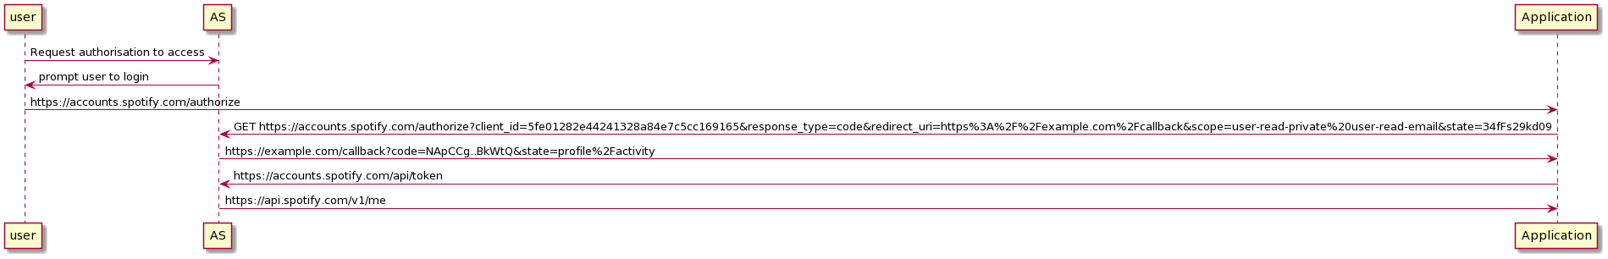

-Need to include Spotify API & make some changes